## Document management

|  |  |  |  |
| --- | --- | --- | --- |
| **Version** | **Date** | **Author** | **Comments** |
|  |  |  |  |
|  |  |  |  |
|  |  |  |  |
|  |  |  |  |

## Control information

|  |  |
| --- | --- |
|  |  |
|  |  |
|  |  |
|  |  |
|  |  |

Table of contents:

Document management 1

Control information 1

Table of contents: 1

Description 3

Use cases 3

Case 1: Set up default values for customers. 3

Case 2: Create a new customer. 3

Functional specifications 4

Abbreviations 4

Changes of existing functionalities 4

Modify Accounts receivable Parameters Form 4

New functionalities 5

Default values 5

Dependencies and assumptions 7

Issue list 7

Approvals 7

Error: Reference source not found

## Description

The purpose of this development is to ease the introduction of new customers.

## Use cases

### Case 1: Set up default values for customers.

1. Navigate: Accounts receivable> Setup> Accounts receivable parameters> General tab> Customer group
2. Insert a default value in Customer Group field

### Case 2: Create a new customer.

1. Navigate: Sales and Marketing> Common> Customers> All customers
2. Create a new customer
3. Complete Name and Fiscal code fields.
4. Verify if Customer Group value is taken from Sales and Marketing parameters.

## Functional specifications

### Abbreviations

N/A

### Changes of existing functionalities

#### Modify Accounts receivable Parameters Form

The “Customer group” field will be added on CustParameters.

|  |  |  |  |
| --- | --- | --- | --- |
| **Field name (EN-US & EN-GB)** | **Type** | **Position** | **Details** |
| **Customer group**  **Grup client** | String | Account receivable parameters  General tab  Customer group | This field will take values from Accounts receivable> Setup> Customers> Customer group. |

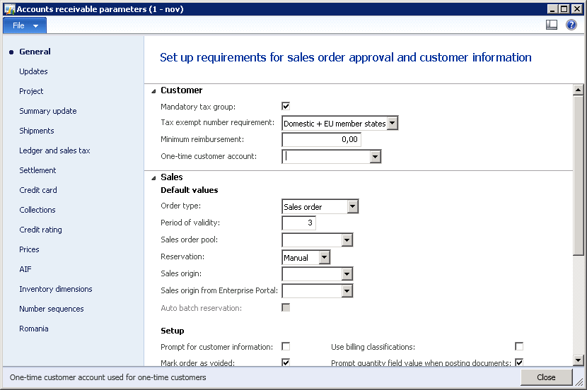

### New functionalities

#### Default values

When a new customer is created, Customer Group must be complete default with value taken from Accounts receivable parameters.

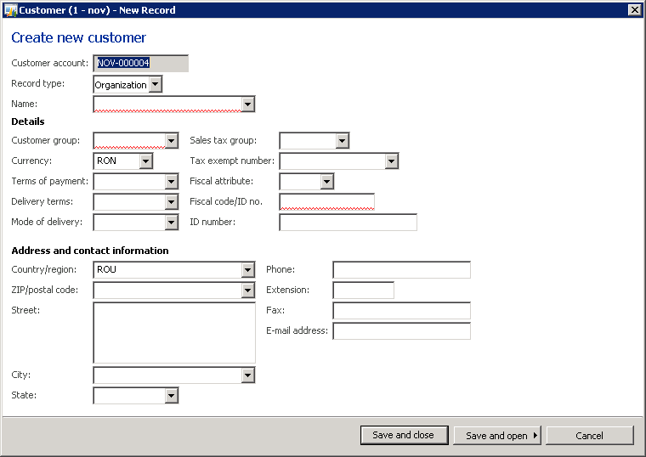

## Dependencies and assumptions

|  |  |
| --- | --- |
| **Description** | **Type (assumption/dependency)** |
|  |  |
|  |  |

## Issue list

|  |  |  |  |  |  |
| --- | --- | --- | --- | --- | --- |
| **Nr.** | **Issue description** | **Found by** | Resolution | Proposed by | **Status** |
|  |  |  |  |  |  |
|  |  |  |  |  |  |
|  |  |  |  |  |  |

## Approvals

|  |  |
| --- | --- |
| **Vendor** | **Customer** |
| Project manager: | Project manager: |